ESL Strategy - Frayer Model
To build students vocabulary, a teacher could incorporate the Frayer Model. This graphic organizer requires the student to define target vocabulary by drawing pictures, listing characteristics, providing examples and using the vocabulary in a sentence to understand the meaning of the word.
How to use
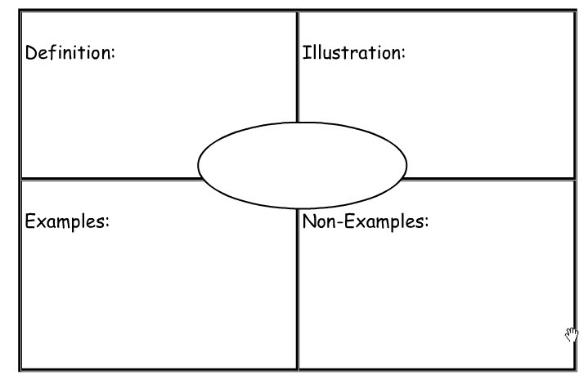
- Create graphic organizer with the desired word centered in a box, which is connected to four additional boxes. Make copies for students with desired word pre-selected.
- Explain the process of the Fryer Model to the students.
- Explain each section of the Fryer Model by using a common vocabulary word as an example.
- Module for the students how to correctly fill in each box, using the common vocabulary word as an example.
- Students may pair up or work independently to complete the Frayer Model.
- Students share their completed Frayer Model with the class.

*Teachers can divide students into groups and assign different vocabulary words that pertain to the lesson to each group. The groups can discuss their assigned words to the class.
*To assess the students understanding of key vocabulary in a lesson, the teacher can set a time limit to complete the Frayer Model.

When to use
Use the Frayer Model to introduce vocabulary and assess understanding of vocabulary.
- At the beginning of a lesson plan to introduce key vocabulary
- At the end of a lesson to assess understanding of vocabulary.
- At the beginning of the school year to assess students understanding of key vocabulary terms.
- Before students begin an assignment in order familiarize the student with vocabulary needed to complete the assignment. (example: science experiments, map projects, math procedures)
- To remind students of important vocabulary term throughout the school year.

Variations
The four descriptive boxes of the Fryar Model can be altered by the teacher for a more in depth understanding of the vocabulary, which may include:
- Examples
- Non-examples
- Thesaurus
- Descriptive Photos
Teachers can allow groups to create their own descriptive labels for the boxes and test other groups within the class
Teachers can fill out the descriptive boxes and ask the students to guess the vocabulary word.
Teachers can use the Pic Collage app for IPad which allows students to create their own Frayer Model graphic organizer. http://pic-collage.com/

(The Teacher Toolkit, n.d.)

ESL Strategy – 3-2-1
The 3-2-1 strategy is a structure that provides information to the teacher allowing them to assess the students understanding of a lesson. The students record their own understanding and summarize their learning within the 3-2-1 structure, thus identifying for the teacher important areas that have been learned or need to be re-taught.
How to use
After a lesson, instruct the students write on a piece of paper:
- Three things that the student has learned from the lesson.

- Two things that the student has found interesting or they would like to learn more from the lesson.

- One question that the student still has about the lesson or the material covered in the lesson.

- Review the information that the student has recorded. This is the most important step of the 3-2-1 strategy. The review enables the teacher to develop future lessons and determine what key elements of the lesson need to be re-taught to the students.

*In a ESL classroom, the students can work together to answer the 3-2-1 strategy. The teacher can record information obtained from the classroom on the whiteboard and have a class discussion.

When to use
Use the 3-2-1 strategy to encourage students to think about what they are learning anytime during the lesson.
- Before a lesson to find a base line of knowledge about an upcoming lesson.
- During a class discussion to see how the students learning has progressed through the lesson.
- Before a review to identify what need to be re-taught before an upcoming exam.
- In between lesson to identify prior knowledge for an upcoming lesson.
- As an exit ticket at the end of a lesson or class period.
Variations
Compare and Contrast 3-2-1
Students will record three similarities between two items, two differences, and one question they still have about the items. (May be used in Social Studies, Science, History)
Reading 3-2-1
After reading the text, have students record three of the most important idea from the text, two supporting details for each of the ideas, and one question they have about each idea.

Pyramid 3-2-1
Have students create a triangle and divide it into three sections horizontally. In the bottom section the students record three things that they learned for the day. Two questions that they have are recorded in the middle section. In the top section students record how they are going to apply the learned material to their daily lives.

Inverted Pyramid 3-2-1 (Rose and Thornes)
In the bottom section the students record the most difficult thing about the lesson (this can be simple – I don’t understand the electoral college.) In the middle section the student records two questions they have about the most difficult thing in the lesson. In the top section the student records three things they enjoy about the lesson.

(The Teacher Toolkit, n.d.)

SPED Strategy – Popsicle Sticks
Popsicle sticks is a strategy that creates an equal opportunity for everyone to participate and share responses to the class. By picking a popsicle stick with the student’s name on it during a discussion, students are treated equally and helps with classroom management.
How to use
- Create
Write the name of each student on individual popsicle sticks. Place the popsicle sticks for the entire class into a cup or a mug. If the students are divided into teams, you may put the team name on the popsicle stick instead of the student’s name. If the class has five teams, then the teacher would create only five popsicle sticks.

- Select
After asking a question to the class, draw a popsicle stick out of the cup or mug. The student that is listed on the popsicle stick will answer the question. In a team environment, the team is responsible for answering the question. If the student, or team is unable to give the correct answer, another popsicle stick may be drawn for additional help. When the correct answer is given, the initial student must repeat what the second student said. This technique does not allow for the initial student to “opt-out” of answering the question.
When to use
Popsicle sticks can be used at any point of the lesson. The strategy increases engagement for the entire class and allows for the teacher to show that every students participation is valuable to the classroom.
- To ask engaging questions to assess prior knowledge before the beginning of a lesson.
- To decide class roles at the begging of a week. (who gathers papers, who makes sure the class in clean before leaving, who is the team captain)
- To randomly call on students to assess understanding during the lesson.
- To line up students prior to leaving the classroom.
- To assign teams for classroom trivia games.
Variations
Make your own popsicle stick – Have students create their own popsicle stick, this allows for students to express themselves in a creative way.
I’m Done – Create an “I’m Done Cup” that students can choose from when they have finished their work early. These popsicle sticks are labeled with tasks for students to do during extra time, examples include: study vocabulary words, play an educational game on the computer, read a book, write a letter to a teacher or pen pal.

Popsicle Stick App
Stick Pick is an Apple IPad app that functions like Popsicle Sticks in your classroom. (http://itunes.apple.com/us/app/stick-pick/id436682059?mt=8)

(The Teacher Toolkit, n.d.)
ESL-Content Cognitive Dictionary (CCD)
Content Cognitive Dictionary (CCD) is a chart that is displayed in the classroom. The teacher adds a new word to the chart, and with student input, the chart is completed with definitions, meaning, sentences, and pictures. The CCD enables a student to acquire understanding of new vocabulary using critical thinking, cooperation, and total body responses. The CCD chart is visited often and always visible to students.
How to use
- Prep For CCD – Create a space in the classroom where you can create the chart. The chart needs to be large enough to be easily read. Segment the chart into 4 sections, each labeled: New Word, Prediction, Final Meaning, Oral Sentence. Use a black marker for the labels, and various other colors for the rest of the words. Prepare a list of vocabulary words that you would like the students to know.
- Introduce The Word – Write the word in colored maker on the chart. Say the word and have the students repeat the word multiple times, in different ways (whisper, loudly, to the ceiling, to the floor, to a partner). Ask if the students who has or has not heard the word. Label and explain the parts of speech (noun, adjective, verb).
- Student Predict – Students work in groups to predict the meaning of the word. These predictions do not need to be perfect examples of what the word means. Transcribe the predictions and re-read the predictions as a group.
- Synonym & Total Physical Response – Introduce a synonym for the word (this should be determined by the teacher prior to the lesson). Introduce a TPR. Say the synonym and do the TPR at the same time (if the word is valley, the teacher could make a “V” motion with their hands). Practice saying the word and the TPR together as a group and continue throughout the day. End of Day One.
- Final Meaning – On the second day, review the new word, say the word with the class using the TPR. Have students talk with one another to determine the final meaning of the word.
- Oral Sentences – Teacher gives an example of the word used in a sentence. Students practice together. Students share sentences orally. Once students have shared the word in sentences, check the word off.
- Begin A New Word
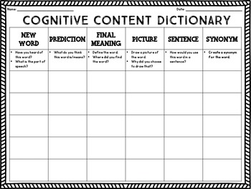
When to use
- Use CCD at the beginning of a lesson to identify key vocabulary.
- During the lesson to assess the understanding of key vocabulary.
- At the end of a lesson to keep the vocabulary fresh for the students.
- Before a unit test to re-introduce students to import vocabulary.
- Cover the CCD chart and have the student teams challenge each other.
- To practice new vocabulary
Variations
CCD charades- Cover the chart and have the students play a game of charades using the TPR motions. Give a team a vocabulary word from the CCD chart and team acts out the word using the TPR motion. Other teams then guess which word is being acted out.
CCD pictures – Have student find pictures that would illustrate the word and attach them to the chart.
CCD scavenger hunt – Have students locate CCD vocabulary in books and magazines and share their findings with the class. The teacher may give the students a list of words and they could photograph an example of the meaning or the words (experiment-the students could photograph students preforming an experiment in a classroom)
(Sanchez, 2015)

SPED – Classroom Centers
Classroom Centers are an effective way to group students. Each center is specialized in one area (math, reading, map reading) or level. The self-explanatory and self-guided centers are self-contained in terms of instruction and lesson materials. This allows for the teacher to rotate among the different centers and provide guidance if needed.
How to use
- Create, Communicate, and Practice Procedures – Create centers that focus on the student’s personal strength and interests. Communicate what is expected from the student in each center. Identify the location of center instructions. Practice the procedures of moving from one center to another center.

- Group With Intention – Tie the centers into your curriculum, provide clear objective and instructions. Include a variety of activities to engage different types of learners (hands on, visual, reading activities).

- Set a Time Schedule for Using the Centers – Allow for enough time for students to finish a project and to move on to a different center.

- Provide inviting environments – A cozy corner to read, attractive decorations, or an area that is different from the classroom (jungle area with stuffed animals with vines draped over fixtures)

- Assign Center Groups – Group students to 3 to 5 per center.
When to Use
- On a rainy day when students cannot go outside.
- In the morning before the beginning of a lesson.
- After students have completed a lesson.
- As a classroom reward for good behavior.
- To introduce new material in fun, engaging manner (map reading – have students construct a buried treasure map)
Variations
- Allow students to give ideas for new centers.
- Create a drama center where students can dress as characters and act out topics in a lesson.
- Mix up the rotation and have students choose which center they would like to go to.
- Invite students to contribute to the centers by adding personal artifacts and decorations.

(Shalaway, 2005)

References
Sanchez, A. (2015, October 8). Laugh, Eat, Learn. Retrieved from Building Vocabulary Through A "CCD" + "Freebie": https://laugheatlearn.com/building-vocabulary-through-ccd/
Shalaway, L. (2005). Scholastic. Retrieved from The New Teacher's Guide to Setting Up Learning Centers: https://www.scholastic.com/teachers/articles/teaching-content/new-teachers-guide-setting-learning-centers/
The Teacher Toolkit. (n.d.). Retrieved from 3-2-1 Strategy: http://www.theteachertoolkit.com/index.php/tool/3-2-1
The Teacher Toolkit. (n.d.). Retrieved from Frayer Model: http://www.theteachertoolkit.com/index.php/tool/frayer-model
The Teacher Toolkit. (n.d.). Retrieved from Popsicle Sticks: http://www.theteachertoolkit.com/index.php/tool/popsicle

